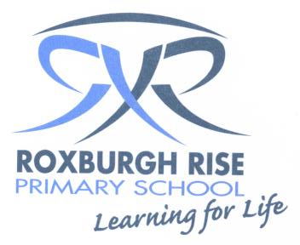
Year 5 Term 4 Overview 2017

Dear Parent/Guardians,

Please find an outline of the grade 5 teaching and learning programs for Term 4. Due to the wide range of student abilities in each classroom, the teaching and learning program will be structured so that the learning needs of each student are catered for. Students will also be using their tablets to deepen their understanding of concepts, raise engagement levels and support personalised learning through all areas of the curriculum.

English: | Reading sessions will involve a variety of learning experiences related to a range of texts. Students will be grouped with other students of like needs. Students will be exposed to effective comprehension strategies that help them to analyse information, integrate and link ideas from a variety of print and digital sources. Some of these include:
 | - Summarising  - Synthesizing  - Main idea |  | - Sequencing  - Annotating  - Comparing & Contrasting
 | Writing sessions will concentrate on the processes of Planning, Composing/Recording, Revising and Publishing their writing during Writer’s Notebook sessions. They will also be learning about the structure of information reports and will have a go at writing some.
Speaking & Listening will be a daily event in the classroom during sharing/reflection sessions. Students will be provided with opportunities to learn about and practice using formal and non-formal language.

Students will also be presenting their homework (news article response and two week topic projects) and inquiry projects to an audience of their choice at the end of the term.
 | Spelling is a part of the writing process. Students are exposed to a word wall which incorporates Inquiry Unit topic words. Spelling skills and strategies will be developed through spelling investigations each week which will focus on the student’s needs. We will particularly be focusing on grammar and punctuation.
Mathematics: | Number:  - The four opeations  - Fractions  - Problem solving tasks | Measurement and Geometry:  - Symmetry  - Angles |  | Statistics and Probability:  - Probability
Inquiry Learning: | The students will be investigating about ‘how technology has changed our lives’  - We will be having a whole school ‘technology free’ day  - Students will be researching about how technology has changed our lives and designing a piece of technology for the future  In Science students will be learning about Earth and Space, where we will be focusing on the following:  - Understanding of how the Earth orbits the Sun while rotating on its axis  - Characteristics of objects in the Solar System
Social & Emotional Learning | Social and emotional learning is incorporated into our day to day program. Students will be involved in mindfulness, meditation and confidence building activities throughout the term.
Homework | - News Reports (weeks 1-5)-Students will be required to watch the news or read a newspaper article which they then need to summarise to report back to the group.  Topic of choice (weeks 6-9)-Students will be required to choose a topic of their choice to research and present to the class.  - Reading - Students to read a book for 20 minutes each night and record the title, pages read and a parent signature in their diary.  - Maths - Students to practise their multiplication and division facts that they are working on each night.  - Writing - Students to complete one page of their MacWrite book each week.

Kind regards,
Year 5 Teachers

Maria Michael, Sarah Wilkinson, Sarah Carroll, Lauren Walker, Brooke Paterno, Con Corso & Kim Carroll

