3.45 POLICY STATEMENT: Student Engagement
PREPARED BY: S. Bannister
REVIEWED: December 2017 (Susan Bannister)
APPROVED BY COUNCIL: May, 2016

Introduction

All Victorian government schools are required to develop a Student Engagement Policy which articulates the school community’s shared expectations in the areas of student engagement, attendance and behaviour. The policy supports the rights and articulates the expectations of every member of the school community to engage in and promote a safe and inclusive educational environment. The Department is committed to providing safe, secure and stimulating learning environments in all Victorian government schools. Students can reach their full educational potential only when they are happy, healthy and safe, and when there is a positive school culture to engage and support them in their learning. Student wellbeing and student learning outcomes are inextricably linked, and schools should aim to promote an understanding of this link in both the school environment and in the classroom. It is fundamental to acknowledge that each teacher is a vital source of support and a determinant in the success of their students.

Definitions
Student engagement can be defined as three interrelated components: behavioural, emotional and cognitive:

Behavioural Engagement
  - refers to students’ participation in education, including the academic, social and extracurricular activities of the school.

Emotional Engagement
  - encompasses students’ emotional reactions in the classroom and in the school and measures a students’ sense of belonging or connectedness to the school.

Cognitive Engagement
  - relates to a students’ investment in learning and their intrinsic motivation and self-regulation.

Purpose
- To relate to and be consistent with the ‘Effective Schools are Engaging Schools: Student Engagement Policy Guidelines’, in areas such as the encouragement of educational achievement and excellence, prevention of absences and inappropriate behaviour.
- To foster a healthy school culture in which high levels of achievement take place within a positive social environment through engagement.
- To provide students with a safe learning environment where the risk of harm is minimised and students feel physically and emotionally secure.
- To provide support for individual circumstances when a student begins to disengage from their learning, when regular attendance is not consistent or positive behaviours are not demonstrated.
- To maximise student learning opportunities and performance through engagement.
- To provide genuine opportunities for student/parent participation and student/parent voice.
- To build a school environment based on positive behaviours and values.
- To provide prevention (cognitive, behavioural and emotional) and intervention for all students at risk.

School Profile Statement

Roxburgh Rise Primary School (RRPS) opened January 2005 and is situated in Roxburgh Park, a residential suburb in the City of Hume, approximately 20km north of Melbourne CBD. RRPS is a modern, well equipped school with sixteen permanent multi-purpose teaching and learning areas, as well as seven relocatable classrooms. Other facilities include a music room, library, art and craft room, canteen, full sized gymnasium, ICT centre and comprehensive administration area. The school has been constructed with attractive landscaped passive and playing areas, as well as modern sporting facilities.

The school officially opened with an enrolment of 114 students and by February of 2016, enrolment had grown to over 800, with students enrolling across all year levels. Of the students currently at the school around 40% come from English speaking homes with 26 other language backgrounds represented. The largest single groups are Turkish, Assyrian and Arabic. The Student Family Occupation density is approximately 0.70, which places the school toward the high end of socio-economic disadvantage, at about the 15th percentile of the state.

The school is student and curriculum focused. It strives for and encourages maximum achievement in all areas of teaching and learning and student wellbeing. Enrichment programs include camping, swimming, transition, excursions and interschool support. An art fair and school concert are significant whole-school events held every two years. Intervention programs such as Discovery Learning, Talk and Play, Perceptual Motor Program, Making a Difference and Reading and Literacy Intervention aim to improve student educational outcomes. A speech pathologist provides both group and individual therapy and assessment. A registered psychologist fulfils the full time role of Student Wellbeing Officer and provides cognitive, social and emotional interventions. Disabled students are supported through the Program for Students with Disabilities. Integration aides and multicultural aides provide specialised and targeted support.

Through its mission and vision statements, RRPS is committed to providing all students with opportunities to become successful life-long learners and to provide a comprehensive curriculum that improves student learning in a safe, caring and challenging environment. It purses this objective through presenting carefully planned and targeted programs that are designed to meet the needs of all students. A whole school social and emotional program, You Can Do It! was introduced in 2008 and teaches students about the foundations of success. A whole school approach to Drug Education is taught throughout the school that is developmentally and age appropriate. A School Community Drug Education grant led to the initiation of a Peer Support Program. Students are encouraged to develop leadership skills through taking on roles with responsibility such as School Captains, Junior School Council and the buddy program. We are a KidsMatter Primary School.

Parents are encouraged to communicate regularly with the school about their child’s education and wellbeing and to visit the school both informally and formally. Parents play an essential role in ensuring their child attends school and shows positive behaviours whilst at school. The school relies heavily on parents to support the staff in establishing positive attitudes to learning and developing independence and responsibility in their students. Students who are living under difficult circumstances are supported with the assistance of the student wellbeing officer. Parents of these students are also offered support both emotionally and financially by being directed to the most suitable agency that can accommodate their needs.

Whole-School Prevention Statement

At RRPS, our positive school culture is predicated on student engagement being the basis for learning. To support this, our leadership team is actively engaged in developing classroom practice to ensure that our pedagogy and curriculum engages all students. Effective teaching, inclusive and engaging curriculum and respectful relationships between staff and students is promoted through professional learning teams that encourage innovative pedagogy.

Roxburgh Rise Primary School’s vision is to provide all students with opportunities to become successful life-long learners, in accordance with our school motto, “Learning for Life”. Our mission statement is to provide a comprehensive curriculum that improves student learning in a safe, caring and challenging environment. We strive to create a positive school culture, free of bias and bullying and where the rights and responsibilities of all community members are accepted and respected. We aim to build and maintain a safe and supportive school environment, with supportive transition programs, and activities promoting positive, supportive and respectful relationships that value diversity. Our approach to encouraging positive behaviour is based within a framework of values, codes of cooperation and rights and responsibilities (as outlined below). We promote pro-social values and behaviours. Programs such as “You Can Do It” and restorative justice practice help to encourage and strengthen the social and emotional capabilities of our students. We also believe it is vitally important to recognise student effort and to provide opportunities for children to participate in a range of positive activities. Programs and strategies are being implemented by RRPS to promote student engagement, high attendance and positive behaviours. An overview of these strategies is outlined below:

- Student conferences provide opportunities for students to share goals and reflections with their parents/carers and share new/modified goals for the coming semester/term.
- Students at Roxburgh Rise have the opportunity to be productively involved in a range of extracurricular activities.
- Student leadership programs such as School Captaincy, Peer Mediation, Junior School Council and other roles of responsibility provide opportunities for students to influence change within the school community.
- Student voice is encouraged through the use of thinking tools which are incorporated into the curriculum.
- Intervening early to identify/respond to student needs for social and emotional support.
- Providing a range of opportunities for students to be involved and feel connected to the community.
- Recognising and responding to the diverse needs of our students through the PSD Support program.
- Adaptation of current pedagogical knowledge and thinking to engage students in meaningful learning experiences.
- Students are encouraged to achieve full attendance to maximise their ability to learn and our teachers’ ability to teach effectively.
- The school’s student wellbeing officer utilizes preventative and early intervention approaches when responding to individual students.
- Whole school approach to Restorative Practices to encourage engagement; build pride, respect and responsibility.
- Development of intensive literacy and numeracy improvement strategies implemented as part of the school improvement agenda and in response to the changing demographics.
- Professional learning is given high priority to ensure strategies and approaches are adopted and implemented.
- Collaboration with other schools through network and cluster arrangements is an important way for schools to work together to develop shared approaches for students at risk of disengagement.
- Student engagement is encouraged through the use of positive recognition and extracurricular activities. Positive recognition may be in the form of tangible rewards or may involve privileges.
- The school provides multiple opportunities for proactively engaging parents/carers and the wider community to be involved in the school’s programs. In particular, the school aims to
  - Ensure all parents are aware of the school’s Student Engagement Policy
  - Conduct effective school-to-home and home-to-school communications
  - Provide volunteer opportunities to enable parents/carers and students to contribute
  - Involve families with homework and other curriculum-related activities
  - Involve families as participants in school decision-making
  - Coordinate resources and services from the community for families, students and the school
  - Provide opportunities to enhance parenting knowledge and skills

POSITIVE BEHAVOIUR MATRIX
At Roxburgh Rise Primary we believe in a consistent whole-school approach to discipline and student management. As a school, we have devised a set of school rules that overlay everything we do.

Rights: Everyone has the right to work and learn; Everyone has the right to be safe and comfortable.
Values: Respect, Inclusiveness, Support, Excellence | School Zone/Time | Individual Responsibility  Students should…. |  |  | Communal Responsibility  Students should encourage others to…
 | Learning Spaces | -have the correct equipment ready to use  -listen when others are speaking  -be punctual  -attempt all work  -move themselves and objects safely  -speak politely  -keeps hands to themselves  -accept responsibility for their own actions |  |  | -organise their equipment  -listen when people are speaking  -be punctual  -attempt and support learning  -move themselves and objects safely  -speak politely using an inside voice  -keep hands to themselves  -protect and defend the rights of all
 | Yard | Piazza:  -hold sports equipment  -walk  -sit down and eat  -choose appropriate games and activities  -be SunSmart  -take turns  -include others  -use the bins | Oval & Basketball Courts:  -choose appropriate games and activities  -be SunSmart  -take turns  -include others  -be aware of others  -respect the property of others  -only kick balls on the oval | Playground:  -choose appropriate games and activities  -be SunSmart  -take turns  -include others  -be aware of others  -use the equipment safely | -hold sports equipment in the piazza  -walk in the piazza  -sit down and eat in the piazza  -choose appropriate games and activities  -be SunSmart  -take turns  -include others  -use the bins  -be aware of others  -use the equipment safely
 | Toilet | -flush the toilet and check it is clean and clear  -wash their hands and conserve water  -wait, take turns and respect the privacy of others  -keep the space clean and tidy  -alert the teacher of any issues  -try to use toilets outside of learning time |  |  | -flush the toilet and check it is clean and clear  -wash their hands and conserve water  -wait, take turns and respect the privacy others  -keep the space clean and tidy  -alert the teacher of any issues  -use toilets outside of learning time
 | Cyber | -follow the Digital Technology User Agreement  -use devices only during learning time  -keep password and personal information private  -only look at or say things online that they would say out loud in front of their teacher and class  -seek permission before posting photos or information about others |  |  | -follow the Digital Technology User Agreement  -use devices only during learning time  -keep password and personal information private  -only look at or say things online that they would say out loud in front of their teacher and class  -seek permission before posting photos or information about others
 | Assembly | -enter & exit the gym in an orderly manner  -sit up straight with legs crossed  -track and listen to the speaker  -Show respect and manners  -be prepared when presenting |  |  | -enter & exit the gym in an orderly manner  -sit up straight with legs crossed  -track and listen to the speaker  -show respect and manners  -be prepared when presenting
 | Main Office/  School entry | -enter and exit through the pedestrian gates  -use an inside voice and manners  -only be in the office area for office related business |  |  | -enter and exit through the pedestrian gates  -use an inside voice and manners  -only be in the office area for office related business
 | End of recess/  lunchtime | -stop what they are doing when they hear the music and walk to their classrooms before the bell goes  -line up quietly with their grade in their line up areas  -walk in an orderly manner into their classroom when instructed by their teacher |  |  | -start walking to line up when the music begins  -line up in a straight line  -walk into their classroom quietly when instructed by the teacher

Outside Cooperation - “The 3 Steps”
Another important part of the Start Up Program is the introduction and repeated exposure of the students to the “Three Steps” method of handling any problems in the classroom or playground. The students are taught to speak up when someone upsets them, to say “Stop, I don’t like it” and to seek help from the teacher if the behaviour continues after they have walked away. “The 3 Steps” aims to assist students to develop basic skills for handling conflict situations in the playground. The strategy can be learned, practised and reinforced through role plays in the classroom.
- Step 1: Look at the person and tell them that you don't like what they are doing. For example, “I don’t like you calling me names”.
- Step 2: Give them a warning that you will tell the teacher if they keep doing it. Then walk away.
- Step 3: Tell the teacher on yard duty.

Rights and Responsibilities

Guiding principles
Every member of the school community has a right to fully participate in an educational environment that is safe, supportive and inclusive. Everyone deserves to be treated with respect and dignity. At RRPS we expect high standards of student behaviour based on cooperation, mutual responsibility and self discipline. We promote positive, non-discriminatory relationships among students, parents, staff and the wider community. The following legislation needs to be considered when determining rights and responsibilities of all members of the school community:

1. Charter of Human Rights and Responsibilities Act 2006
2. Equal Opportunity Act 1995
3. Disability Discrimination Act 1992 (in conjunction with DET Disability Standards for Education 2005)
4. Education and Training Reform Act 2006
5. Education Act 1958

The Charter of Human Rights and Responsibilities Act 2006
The Charter sets out a list of 20 rights that reflect the following four basic principles:
- Freedom
- Respect
- Equality
- Dignity
The Charter of Human Rights and Responsibilities Act (2006) outlines a vision of human rights for all Victorians. The charter affirms that all people are born free and equal in dignity and rights. While the charter demands equality for all, it also emphasises the value of difference. The charter requires public authorities, including government schools and their employees, to act compatibly with human rights and to consider human rights when making decisions and delivering services. All DET employees must act compatibly with the Charter and give proper consideration to human rights when making decisions. Everyone should:
- Encourage compliance with the Charter
- Support others to act compatibly with the Charter, and
- Respect and promote human rights

Equal Opportunity
The Equal Opportunity Act 1995 sets out the types or grounds of discrimination that are unlawful and aims to promote community recognition and acceptance of the equality of men and women, and the equality of people of all races, regardless of their religious or political convictions, their impairments or their age. Under the act it is unlawful to discriminate against a person on the basis of the following attributes:
- age
- breastfeeding
- gender identity
- impairment
- industrial activity
- lawful sexual activity
- marital status
- parental status or status as carer
- physical features
- political belief or activity
- pregnancy
- race
- religious belief or activity
- sex
- sexual orientation
- personal association (with a person who is identified by reference to any of the above attributes).

Students with disabilities
The Disability Standards for Education 2005 clarify and make more explicit the obligations on schools and the rights of students under the Disability Discrimination Act 1992. The standards cover enrolment, participation, curriculum development, student support services, and harassment and victimisation. An education provider must make ‘reasonable adjustments’ to accommodate a student with a disability. An adjustment is a measure or action taken to assist a student with disability to participate in education and training on the same basis as other students. An adjustment is reasonable if it does this while taking into account the student’s learning needs and balancing the interests of all parties affected, including those of the student with the disability, the education provider, staff and other students. In determining whether an adjustment is reasonable, an education provider should take into account information about:
- the nature of the student’s disability
- his or her preferred adjustment
- any adjustments that have been provided previously
- any recommended or alternative adjustments.
This information might come from the student, an associate of the student, independent experts, or a combination of these people. An education provider should ensure that the student, or an associate of the student, has timely information about the processes for determining whether the proposed adjustment would cause unjustifiable hardship to the provider. The provider should also ensure that these processes maintain the dignity, respect, privacy and confidentiality of the student and the associates of the student, consistent with the rights of the rest of the community.
The provider may consider all likely costs and benefits, both direct and indirect, for the provider, the student and any associates of the student, and any other persons in the learning or wider community, including:
- costs associated with additional staffing, providing special resources or modifying the curriculum
- costs resulting from the student’s participation in the learning environment, including any adverse impact on learning and social outcomes for the student, other students and teachers
- benefits of the student’s participation in the learning environment, including positive learning and social outcomes for the student, other students and teachers, and
- any financial incentives, such as subsidies or grants, available to the provider if the student participates.
The DDA and the Education Standards do not require changes to be made if this would impose unjustifiable hardship to a person or organisation.

Bullying and harassment
Every member of the school community has a right to fully participate in an educational environment that is safe, supportive and inclusive. Everyone deserves to be treated with respect and dignity. At Roxburgh Rise Primary School, everyone has the right to learn and the right to feel safe. Teachers also have the right to teach. RRPS will provide a safe school environment that is free of harassment and bullying. All persons have a legal right to protection from harassment under the Commonwealth Sex Discrimination Act and the Victorian Equal Opportunity Act. The effects of harassment or bullying include
- poor health – anxiety, depression
- lower self esteem
- reduced study performance
- missed classes, social withdrawal
- reduced career prospects

If a student sees another person being harassed or bullied they should tell the person that you witnessed the incident and advise them to report it to an appropriate person. However, if your friend is harassing another person, let them know that their behaviour is unacceptable. Bystanders who do nothing to stop bullying may be contributing to the problem by providing an audience for the bully.

Harassment
is any verbal, physical or sexual conduct (including gestures) which is uninvited, unwelcome or offensive to a person. Harassment is usually directed at a person because of their gender, race, creed or abilities. It can be subtle or explicit. Subtle harassment includes:
- Offensive staring and leering.
- Unwanted comments about physical appearance and sexual preference.
- Racist or smutty comments or jokes.
- Questions about another’s sexual activity.
- Persistent comments about a person’s private life or family.
- Physical contact e.g. purposely brushing up against another’s body.
- Offensive name calling.
Explicit harassment includes:
- Grabbing, aggressive hitting, pinching and shoving etc.
- Unwelcome patting, touching, embracing.
- Repeated requests for dates, especially after refusal.
- Offensive gestures, jokes, comments, letters, phone calls or e-mail.
- Sexually and/or racially provocative remarks.
- Displays of sexually graphic material– pornography.
- Requests for sexual favours.
Extreme forms of sexual harassment will lead to criminal prosecution.

Bullying
is repeated oppression, physical or psychological, of a less powerful person by a more powerful person or group. Bullying can involve such things as
- grabbing, aggressive staring, hitting, pinching kicking, pushing and shoving
- publicly excluding a person from your group
- taking or breaking a person’s property
- knocking a person’s books or belongings out of their hands or off their desk
- teasing a person because of their looks

Cyberbullying
is a form of bullying which is carried out through an internet service such as email, chat room, discussion group, online social networking, instant messaging or web pages. It can also include bullying through mobile phone technologies such as SMS. It may involve text or images (photos, drawings). Cyberbullying can happen to anyone and the bully can act anonymously. People can also be bullied online by groups of people such as class groups or collective members of an online community. Examples of cyberbullying behaviour are:
- teasing and being made fun of
- spreading of rumours online
- sending unwanted messages
- defamation.
Being involved in online spaces – either at home or at school - requires students to behave responsibly. This includes:
- the language you use and the things you say
- how you treat others
- respecting people's property (eg copyright)
- visiting appropriate places.
Behaving safely online means:
- protecting your own privacy and personal information (we used to call it 'stranger danger')
- selecting appropriate spaces to work and contribute
- protecting the privacy of others (this can be sharing personal information or images)
- being proactive in letting someone know if there is something is 'not quite right'. At home this would be a parent or carer, at school a teacher.
If you are being harassed or bullied you should tell the person you don’t like what they are doing and you want them to stop; and discuss the matter with a student leader or a teacher/coordinator that you feel comfortable with. Your concerns will be taken seriously. All complaints will be treated confidentially.

All members of the school community - students, teachers and parents have rights and certain responsibilities that must be recognised and accepted by members of the school community. A positive learning environment comes about when students, teachers and parents are involved in the learning process and have had their rights and responsibilities clearly defined. A right is something to which you are entitled. Responsibilities are the things that people should do without being told.

Staff Rights and Responsibilities

Staff have a right to…. | Staff have a responsibility to….
- feel valued as a person and as a professional. | - make every effort to value others in the school community.  - ensure a professional approach to their work.
- teach without disruption. | - provide quality teaching and an appropriate curriculum.
- be shown courtesy and consideration by all in the school community. | - treat all in the school community- pupils, staff, parents- with care, courtesy and consideration.  - offer support to colleagues.
- work in a safe and supportive community. | - promote a safe and supportive environment for others.
- have the support of the parents of the pupils with whom we work. | - keep parents informed about the curriculum and the progress of their children and invite their involvement.
- have the opportunity to teach a broad, balanced and differentiated curriculum with appropriate resourcing. | - allocate appropriate time to plan, evaluate and monitor their teaching and their pupil’s learning.  - be actively involved in whole school planning and policy making.
- have the opportunity for professional development. | - take responsibility for their own professional development.
- have personal property and that belonging to the school respected. | - respect the property of others.
- work in a clean, tidy and orderly environment. | - promote a clean, tidy and orderly environment and help take responsibility for common areas such as corridors, storeroom and yard.

A Note About Staff and Attendance
Student attendance is the responsibility of everyone in the community. All staff are required to have high attendance expectations. Teachers are required to take responsibility for documenting student absences and maintaining accurate attendance records, including reasons for absence.

Parents Rights and Responsibilities

Parents have a right to…. | Parents have a responsibility to….
- be kept informed about your child and the school in general. | - support the education of your child.  - make every effort to be kept informed.  - be involved in the activities of the school.
- express yourself on school matters. | - provide the school with information, which may be relevant to your child’s behaviour at school.
- have access to school personnel at mutually acceptable times. | - try to ensure that the time taken to speak with teachers does not take them away from teaching duties and classroom responsibilities.
- be treated with respect and have your opinions valued. | - respect the staff of the school and value their opinions.
- expect that your child will be safe at school and treated fairly. | - promote acceptable behaviour in your child.  - encourage your child to understand and accept school rules.
- expect that your child will be given access to a quality curriculum and stimulating learning environment. | - act in partnership with the school to promote your child’s learning.  - make every effort to understand the curriculum being offered to your child.
- know that your child attends a school which takes pride in itself, which is clean, orderly and tidy, and where students take pride in their work. | - help to keep the environment clean.  - ensure that your child is appropriately dressed and prepared for school.

A Note About Parents and Attendance
Regular school attendance is a prerequisite for improving student learning. Student attendance is the responsibility of everyone in the community. Parents are responsible for making sure their child attends school and is on time every day. Parents are also responsible for providing the school with an explanation if the child is away.

Student Rights and Responsibilities

Students have a right to…. | Students have a responsibility to….
- feel safe and secure at school and to work, play and move from place to place without being harassed or bullied. | - help make our school a happy and safe place.  - help to prevent or stop bullying.
- be in an effective learning environment where they can learn as much as they are able without disruption. | - do their best and to respect the rights of others to learn without disruption.  - be punctual.  - meet work requirements.
- be treated with fairness and respect regardless of gender, race, age, disability or impairment. | - treat others (parents, students, teachers) with consideration, tolerance and respect, accept individuality.
- have personal and school property respected. | - respect our school environment. This includes their own property and that of others.
- expect a resolution to their problems, to be able to tell their side of the story in a dispute within a supportive environment and to be taught strategies to solve problems. | - seek to resolve conflict in a positive and co-operative manner.
- be informed of rights, responsibilities and school rules. | - apply rights, responsibilities and school rules appropriately.
- communicate, be listened to and to have opinions valued. | - listen courteously to others, value their contributions and respect their opinions.  - tell the truth and to speak politely and respectfully.
- work and play in a clean, tidy and stimulating environment. | - actively contribute to a clean, caring and safe school environment.
- use and share equipment and facilities. | - use equipment safely and to share with others.

A Note About Students and Attendance
Students are responsible for attending school every day. Students are also responsible for handing explanation notes to their teacher if they are absent, late or need to leave school for any reason.

Shared Expectations

Schools have a responsibility to provide an educational environment that ensures all students are valued and cared for, feel they are part of the school, and can engage effectively in their learning and experience success. Effective schools share high expectations for the whole-school community. RRPS has developed shared expectations to ensure the learning, safety and rights of all are respected. The expectations are intended to be positive in that they set out what are excepted and appropriate behaviors for our school community. Our shared expectations are intended to support individual students and families that come to our community from a diversity of backgrounds, communities and experiences. Ensuring that students attend school each day is the shared expectation of all parents/carers, students and the school. School expectations include:
- inclusive teaching practices
- accessible educational provision for all students
- parent/carer partnerships and liaison
- community partnerships which engage families and the community in ways that support student achievement and success
- provision of appropriate student services
- development and provision of appropriate, relevant and challenging curriculum that gives students the opportunity to experience success in their learning.

School Values

The Roxburgh Rise school values:

Value | What does it mean | What does it look like  (Code of Conduct)
Respect | We behave in ways that show care and consideration for others and our community. | We demonstrate this by:  - Treating everyone how we want to be treated  - Adhering to the school expectations (link to school policy for uniform, attendance, et)  - Listening to other people and valuing what they say  - being kind, caring, and friendly to each other  - Looking after our equipment and resources  - Always doing the right thing  - Caring for our school  - Setting a good example for others
Inclusiveness | We accept and embrace everyone’s similarities and differences. | We demonstrate this by:  - Saying hello to everyone  - Treating everyone equally  - Letting everybody have a go  - Making people feel like they belong  - Learning about each other  - Working together as a team  - Trying new things
Support | We are there for one another | We demonstrate this by:  - Helping each other  - Sharing our things  - Listening to everyone in our community  - Sharing our knowledge/resources/ ideas/time  - Support each other in all we do  - Encourage one another to do our best  - Asking ‘how can I help you?’  - Asking for help when something is too hard.
Excellence | We strive to do our personal best. | We demonstrate this by:  - Being proud and passionate about our learning  - Doing our BEST at all times  - Persisting in all we do  - Setting achievable goals for ourselves  - Recognising our strengths and areas for growth.  - Being active learners and strive to improve our knowledge and skills.  - Reflecting on and understanding how we learn best.

You Can Do It!
Roxburgh Rise Primary School has adopted the ‘You Can Do It Program’ which aims to develop the potential of children academically, intellectually, interpersonally and emotionally. This is achieved by instilling ‘Five Foundations’ which complement the RRPS values: Confidence, Persistence, Organisation, Getting Along & Resilience

Staff Engagement

The school leadership team will;
- uphold the right of every child to receive an education up to the compulsory age of schooling
- ensure the school complies with its duty of care obligations to each student as well as its obligations under the equal opportunity and human rights legislation
- identify the diversity of the school community and deliver teaching and learning, educational and extra-curricular activities and community services inclusive and responsive to student needs.

The staff will;
- develop flexible pedagogical styles to engage different learners
- deliver curriculum and assessment that challenges and extends students learning
- develop positive relationships with students that promote engagement, wellbeing and learning
- provide opportunities for student voice developing a positive school culture

Attendance
In compliance with Departmental procedures school staff will;
- promote regular attendance with all members of the school community and;
- monitor and follow up on absences

Behaviour
RRPS will support and promote positive behaviours by developing and implementing shared behavioural expectations with the school community through a staged response.

The school leadership team will;
- lead and promote preventative approaches to behavioural issues
- monitor the profile of behaviour issues at the school and the effectiveness of implemented strategies
- provide professional development for staff to build their capacity to promote positive behaviours.

The staff will;
- use Student Engagement policy as a basis for negotiating class-based shared expectations with students
- teach students social competencies through curriculum content and pedagogical approach
- employ behaviour management strategies that reflect the behaviours expected from students
- build a collegiate atmosphere with other school staff to share strategies and support each other to reflect on one’s own behaviour management approach

Staff members are made aware of the school’s expectations and policies through a teacher code of conduct. These expectations are reiterated during staff meetings, briefings, and professional learning activities. Please refer to the Victorian Teaching Profession Code of Conduct at http://www.vit.vic.edu.au/content.asp?Document_ID=25.

Student Engagement
All students are expected to;
- respect, value and learn from the differences of others;
- have high expectations that they can learn;
- reflect on and learn from their own differences;

Attendance
All students are expected to come to school every school day throughout the year. (If students cannot attend their
parents/carer must provide a suitable explanation to the school).

Behaviour
All students will;
- support each other’s learning by behaving in a way that is curious and respectful
- have high expectations that they can learn
- be considerate and supportive of others
- demonstrate behaviour and attitudes that support the wellbeing and learning for all and contributes to a positive school environment that safe, inclusive and happy
- understand that bullying, including cyber-bullying, violence, property damage, inappropriate language and disrupting the learning of other students is unacceptable

Parents/Carers Engagement
- parents/carers are expected to support the school’s efforts to educate young people to live in a diverse world by promoting an understanding and appreciation of diversity in the home
- parents/carers should also help the school to provide student-centered responses by providing all relevant information to the school
- parents/carers are encouraged to actively participate in supporting their child’s learning by building a positive relationship with the school
- parents/carers will work with the school through attendance at parent-teacher meetings and responding to communications in a timely manner

Attendance
Parents/carers are expected to ensure that enrolment details for their children are correct, that their children attend school regularly and that, when a child is absent from school, parents/carers advise the school as soon as possible.

Behaviour
Parents/carers should understand the schools behavioural expectations and aim to provide a consistent approach that
supports their child’s learning and engagement in and out of school.

School Actions and Consequences

Student engagement, regular attendance and appropriate behaviours are encouraged through the implementation of whole-school strategies supported by targeted and individualised support when required.

- A staged response applied fairly and consistently.
- Applying fair and consistent discipline and attendance policies that are collectively agreed on and fairly enforced.
- Establishing predictable, fair and democratic classrooms and school environments
- Ensuring student participation in the development of classroom and whole-school expectations
- Providing personalised learning programs
- Consistently acknowledging all students
- Empowering students by creating multiple opportunities for them to take responsibility and be involved in decision-making
- Providing physical environments conducive to positive behaviours and effective engagement in learning
- Implementing school-wide positive and educative behaviour support strategies.
Inappropriate behaviours, including irregular attendance, will be responded to through a staged response, including:
- understanding the student’s background and needs
- ensuring a clear understanding of expectations by both students and teachers
- providing consistent school and classroom environments
- scaffolding the student’s learning program.
Broader support strategies will include:
- involving and supporting the parents/carers,
- involving the student wellbeing coordinator
- tutoring/peer tutoring
- mentoring and/or counselling
- convening student support group meetings – the student support group is an important component of the staged response for students facing difficulty with engagement, attendance or behaviour
- developing individualised flexible learning, behaviour or attendance plans
- providing broader educational programs, for example experiential learning, work education, camps/outdoor education/creative arts
- involving community support agencies.

Whole School Prevention

At RRPS the promotion of school wide positive values and rights and responsibilities is the first step. The school motto and values are discussed and examined extensively at the beginning of the year as part of the Start Up program in the first two weeks of Term One. These values are regularly revisited throughout the year and when needed. The Right To Learn and the Right To Be Safe and the Right to Teach and their corresponding responsibilities are also explained and discussed at this time because they underpin the behaviour management policy of the school and form the basis for the language which the teachers use in the classroom. Warnings are given to students who infringe these rights (eg. You are stopping others from learning/ me from teaching. You are making others feel unsafe when you run past like that/yell at them). Praise and verbal recognition is given when students practise positive behaviours and consider other people’s rights in their actions. Students displaying the school values are noticed and celebrated.

As part of the Start Up program each grade develops a Code of Conduct for their classroom with consequences and rewards attached to a positive list of agreed behaviours. Rewards are for individuals as well as for the class as a whole and can include things such as stickers, prizes, computer time and special activities. Consequences are as much as possible linked to the behaviour, for example if a student talks and stop others from learning they may have to sit on their own or if work is not done in a reasonable time they may be asked to stay in at recess and finish it. In response to the infringement of the school’s code of cooperation, any or all of the following procedures should be used:

Managing Inappropriate Behaviours

Roxburgh Rise Primary School has procedurally fair processes for managing student behaviour. Corporal punishment is prohibited in all Victorian schools. Corporal punishment must not be used at the school under any circumstances.

RRPS MISBEHAVIOUR MANAGEMENT

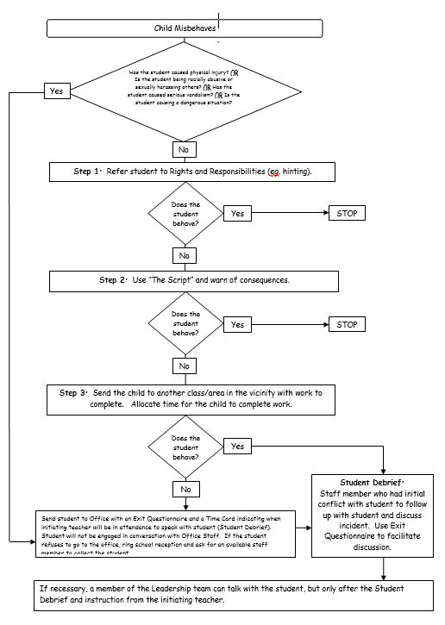

THE SCRIPT
Verbally Controlling Students, (be calm, not hostile)

1. Explain
Body language: open stance, lean forward, eye contact until 3 seconds after explanation. Include the name of student, description of inappropriate behaviour, statement of why it is inappropriate, demand (what to do now).
Eg. Terry………..you’re talking. It’s disturbing others. They have a right to work. Please be quiet.

2. If resistance – reassert
Eg. I understand. If you wish to discuss it, we can do that after the lesson or at lunchtime. Right now, please be quiet.

3. Reassert again (optional)
Eg. That’s not the point. PLEASE…BE…QUIET (said softly)

4. Give choice
Eg. You have a choice. If you aren’t quiet, you will have to ……(have a hierarchy of consequences prepared).

5. Follow Through.
Eg. Please sit over there

If strong resistance is met, don’t get into a power struggle. Defuse the power but increase the level of severity of consequence. Eg. Terry, I don’t intend to force you. However, if you don’t, then I am going to…… The choice is yours. You have 10 seconds to think about it.

Examples of Rights-Based Explanations

Talking when teacher is trying to talk to class
“Terry, you’re talking. These kids can’t hear. Please be quiet (please act responsibly, please be fair.”).
Calling Out
“Terry, you’re calling out. Others have a right to concentrate. Please be quiet.”
Not having equipment
“Terry, you need your equipment to learn. When you borrow from others, it distracts them. Please bring all your things to class.”
Putting down other students
“Terry, Chris has a right to feel comfortable. You are not respecting her rights. Please speak nicely.”
Coming late to class
“Terry, when you come late to class you aren’t being fair. It distracts others. Please come on time.”

The Class Code of Conduct is sent home for parents to read and discuss with their child. It is expected that parents will reinforce and support the school in implementing and maintaining it. High standards are set for learning and behaviour. Emphasis is also placed on developing positive, caring and respectful relationships between teachers and students so that the students feel a strong connection to their teachers, classmates and school community. Students are encouraged to see their teachers and other adults at school as kind people who listen and can help them with any problems they may have at school or home.

Discipline procedures – suspension and expulsion

When considering suspension or expulsion, schools are required to follow the procedures listed in Ministerial Order 625.

Students can be suspended or expelled if, while at school, travelling to or from school or during an out-of-school activity (including travel there and back), their behavior meets one or more of the following conditions:
a) behaves in such a way as to pose a danger, whether actual, perceived or threatened, to the health, safety or wellbeing of any person;
b) causes significant damage to or destruction of property;
c) commits or attempts to commit or is knowingly involved in the theft of property;
d) possesses, uses or sells or deliberately assists another person to possess, use or sell illicit substances or weapons;
e) fails to comply with any clear and reasonable instruction of a staff member so as to pose a danger, whether actual, perceived or threatened, to the health, safety or wellbeing of any person;
f) consistently engages in behaviour that vilifies, defames, degrades or humiliates another person based on age; breastfeeding; gender; identity; impairment; industrial activity; lawful sexual activity; marital status; parent/carer status or status as a carer; physical features; political belief or activity; pregnancy; race; religious belief or activity; sex; sexual orientation; personal association (whether as a relative or otherwise) with a person who is identified by reference to any of the above attributes;
g) consistently behaves in an unproductive manner that interferes with the wellbeing, safety or educational opportunities of any other student.

Please note: For incidents between students that occur outside of school hours or in locations other than those listed above, a suspension cannot be used as a response. The impact of cyberbullying (and other behaviours) outside of school hours/off school premises on schools is acknowledged, however, if the behaviour occurs solely outside of school hours/grounds suspension is not an available recourse. If incidents outside of school hours are connected to behaviour that does meet the grounds and location requirements for suspension, this external behaviour may be considered when determining the response to an in-school incident. ​

In cases of expulsion the student’s behaviour must also be of such magnitude that expulsion is the only available mechanism. In this regard, the principal must consider the need of the student to receive an education compared to the need to maintain the health, safety and wellbeing of other students and staff at the school and the need to maintain the effectiveness of the school’s educational programs.

Under Victorian Law, in deciding whether to expel a student, principals must undertake an assessment of that course of action under the Charter of Human Rights and Responsibilities Act 2006. In addition, when determining whether to expel a student with a disability, principals must be sure that reasonable adjustments have been made to assist the student to manage the behaviours where this is a manifestation of disability. ​

A student should only be excluded from school in situations where all other measures have been implemented without success or where an immediate suspension is the only appropriate course of action in response to the student’s behaviour. Consequences which may be used prior to suspension include:
- Withdrawal of privileges
- Withdrawal from class if a student’s behaviour significantly interferes with the rights of other students to learn or the capacity of a teacher to teach a class, that student may be temporarily isolated from regular classroom activities or, in more severe cases, required to leave the classroom for a specified period of time.
Where appropriate, parents/carers should be informed of such withdrawals.
- Detention - teachers may require a student to finish school work that has not been completed in the regular classroom or to undertake additional or new work or duties at a reasonable time and place. No more than half the time allocated for any recess may be used for this work. Where students are required to undertake school work after school, the time should not exceed forty-five minutes. The principal should ensure that parents/carers are informed at least the day before the detention. Where family circumstances are such that the completion of after-school work would create undue hardship (for example, where students regularly supervise younger siblings in the absence of parents/carers), the school may choose to negotiate alternative disciplinary measures with parents/carers.
- Convening of a support group (See Effective Schools are Engaging Schools - Student Engagement Policy Guidelines for process required).

See Appendices C & D for further information about suspension and expulsion procedures.

Promoting School Attendance

At RRPS, absences often mean students miss important stages in the development of their learning, causing them to find ‘catching up’ difficult. Please refer to RRPS Attendance Policy for further information.

Whole School Strategies
The school will articulate high expectations to all members of the school community about attendance. They will adopt consistent procedures to record student absence and follow up student absences promptly. Notices will be placed in newsletters and on the website about absences and the resultant lost learning that happens when students are absent for extended periods of time. All staff members will be responsible for monitoring student absences. Individual Student Learning Plans that include punctuality and attendance as goals will be enacted for students who are chronically absent. A further more targeted response will be taken when absences are severe. Referral to community agencies for family support may also be needed.

Shared Expectations for attendance
Ensuring students attend each day is a shared expectation of parents, students and the school. Parents are required to make sure their child attends school at all times while the school is open for instruction. Parents are expected to provide educational support for their child and ensure that their child is on time each day. Parents are expected to notify school as soon as possible, preferably on the first day of the child absence or notify the school in advance if this is possible. Parents should support their child’s learning during any prolonged absence by organising a discussion with the class teacher prior to the absence. Parents are expected to work co-operatively with the school if attendance has been inconsistent and unsatisfactory. Students are expected to attend school, to arrive on time and to every class, whenever the school is open for instruction. Students are expected to provide a written explanation from their parent when they have been absent from school. Students should remain on the school premises unless they receive permission to leave from both the school and their parents.

Recording and monitoring attendance
RRPS will ensure attendance is recorded twice a day and pursue and record an explanation for every absence, as in CASES21.

Attendance follow-up
Unexplained absences are followed up through a phone call, letter or email after three days, if no satisfactory response is obtained within 10 school days then the absence is recorded as unexplained. When a student’s attendance pattern is of concern to the school an informal or formal meeting will be convened with the parents to discuss attendance and the support needed for the student/family to resolve the attendance issue. Parents and the school will work together in an effort to improve the attendance of the student.

References

Effective Schools are Engaging Schools - Student Engagement Policy Guidelines | http://pandora.nla.gov.au/pan/128923/20110825-0310/www.eduweb.vic.gov.au/edulibrary/public/stuman/wellbeing/segpolicy.pdf
School Accountability and Improvement Framework | http://www.education.vic.gov.au/school/principals/spag/governance/Pages/accountability.aspx
Disability Standards for Education | http://www.education.vic.gov.au/school/teachers/learningneeds/Pages/legislation.aspx
Bullying Prevention Policy | http://www.education.vic.gov.au/about/programs/bullystoppers/Pages/prinprevent.aspx
Charter of Human Rights | http://www.austlii.edu.au/au/legis/vic/consol_act/cohrara2006433/
Equal Opportunity Act | http://www.education.vic.gov.au/hrweb/divequity/Pages/default_eeo.aspx
Education and Training Reform Regulations 2017 | http://www.education.vic.gov.au/about/department/legislation/Pages/act2006regs.aspx
VIT Codes of Conduct and Ethics | https://www.vit.vic.edu.au/professional-responsibilities/conduct-and-ethics

Appendix C – Procedures for Suspension
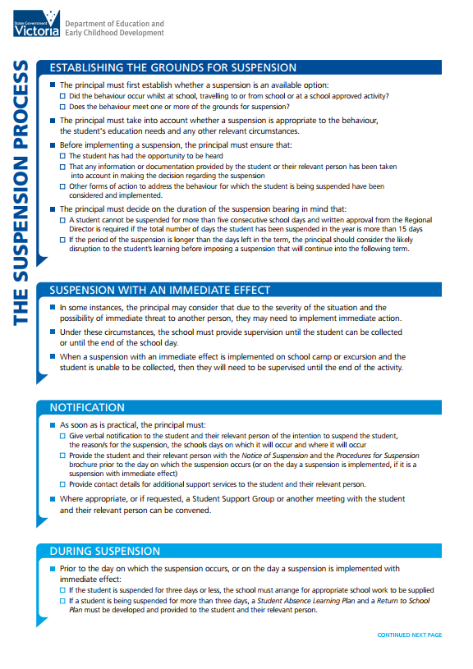
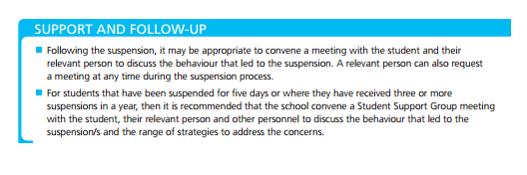
Appendix D – Procedures for Expulsion

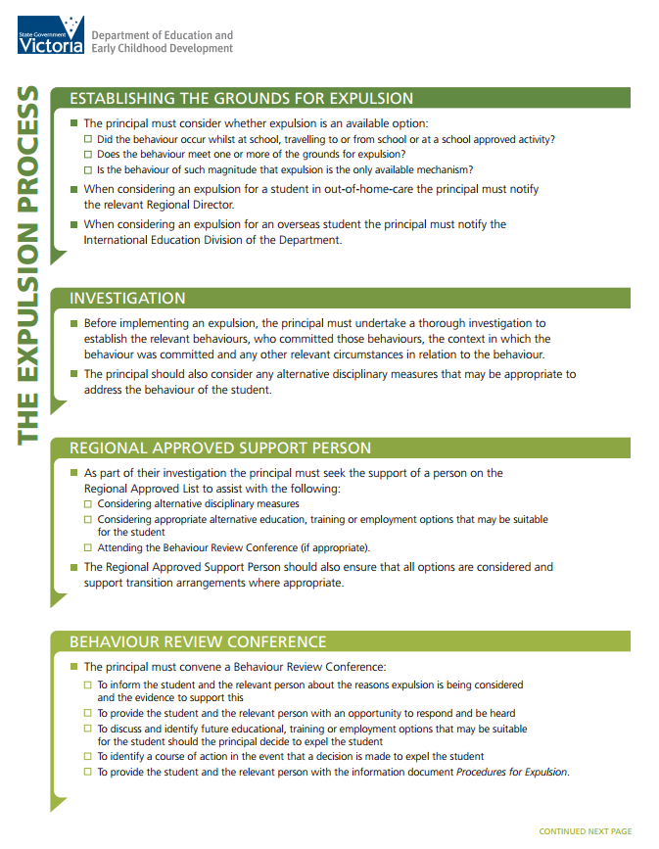
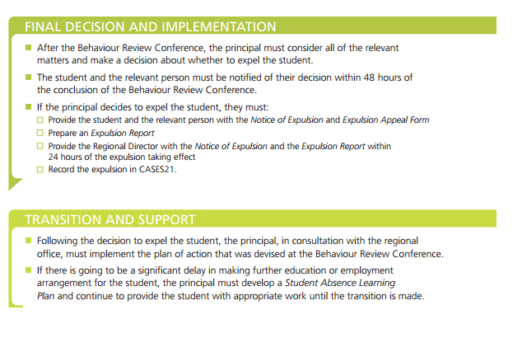

Appendix E – Yard Duty Procedures

Teachers need to model appropriate behaviour at all times. It is vitally important that teachers are consistent in their approaches both within their own classrooms and in the playground. The following process is to be implemented by all staff when on yard duty. When an incident is observed, ask the students what happened, determine the nature of the incident and apply the appropriate consequence.

Incidents in the Playground and Consequences

BEHAVIOUR | CONSEQUENCE | RECORD ON GRADEXPERT?  (Allows for tracking of continuous offenders)
playing in wrong area | Instruct the student to play in their age appropriate area | Yes
teasing or annoying another person | Instruct student to do the ‘3 Steps’. If behaviour does not stop, speak to students involved and ask them to try and resolve the problem. | Yes
conflict between students | Instruct students to discuss the problem as a group and return to the teacher with a solution. | Yes
swearing | “We don’t use that type of language at school” and walking with the teacher picking up papers. | Yes
littering | Picking up papers while following the teacher | Yes
any behaviour that you think will escalate into a problem without your supervision | Chill Chair – any bench in your area where you can supervise the student for a length of time determined by you (no more than half of recess or lunch). | Yes
throwing objects | Office | Complete Exit Card and send to Office.
fighting, kicking/punching | Office | Complete Exit Card and send to Office.
racial abuse | Office | Complete Exit Card and send to Office.
vandalism | Office | Complete Exit Card and send to Office.

Office
If a student is sent to the office they will be required to complete an “Exit Questionnaire” or “Face Up To It Sheet”. The incident is recorded in the “Discipline Log”. Three incidents in the one term will usually mean contact with the parent is made, additional incidents means loss of a major privilege eg: missing out on an excursion, interschool sport, etc.
BULLYING WILL NOT BE TOLERATED AT RRPS. ALL INCIDENTS WILL BE TAKEN SERIOUSLY AND DEALT WITH ACCORDINGLY. (Refer to RRPS Anti - Bullying Policy)

