Year 4 Term 1 Overview 2019 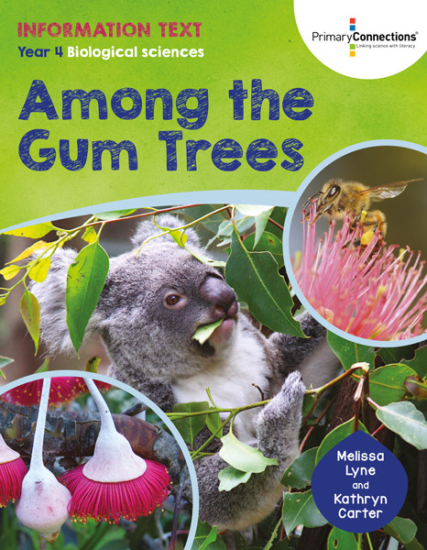

Dear Parents/Guardians,

Welcome to the commencement of Term 1. We hope you all had a safe and fun-filled break. As Term 1 is a Sun Smart Term, please ensure your child has a school hat to wear outside. Please find an outline of the Grade 4 teaching and learning programs for Term 1. Due to the wide range of student abilities in each classroom, the teaching and learning program will be structured so that the learning needs of each student are catered for. Students will also be using their iPads to deepen their understanding of concepts, raise engagement levels and support personalised learning through all areas of the curriculum.

English | Reading Focus:  Reading sessions will involve a variety of activities related to a range of texts. Students will be grouped into guided reading groups or strategy groups and will be working on the four key components of successful reading: Comprehension, Accuracy, Fluency, and Expanding Vocabulary. The focus in reading will be on making connections to themselves, other texts & the world, comprehension, understanding details and facts and details. Students will also be exposed to various forms of texts relating to physical, emotional and social wellbeing.
Writing Focus:
Writing sessions will concentrate on planning, composing/recording, revising & publishing written work in a variety of forms. Students will be exposed to the different characteristics of a range of writing. They will be writing information texts using facts they have researched. The students will also focus on writing personal choice pieces for their Writer’s Notebook.
Speaking & Listening Focus:
Students will have many opportunities to speak in front of others, to encourage & increase their confidence. Students will be encouraged to put into practice the qualities of what makes a good speaker and listener. Students will have the opportunity to share a rap/song they have written with their peers.
Spelling and Grammar Focus:
Spelling and grammar are part of the writing process. Strategies and skills will be developed through spelling investigations, student selected words, grammar workshops and weekly spelling foci.
Maths | During Mathematics sessions this term, students will be learning about the following:
 | Number & Algebra Focus:  - Place Value and Whole numbers  - Addition and Subtraction  - Fraction and Decimals | Measurement & Geometry Focus:  - Shapes and Area  - Length | Statistics & Probability Focus:  - Data representation and interpretation
Inquiry Learning  And Science | The Inquiry Unit for Grade 4 this term is ‘Shaping Our Identity’ and students will be able to explore different emotional health and physical changes to their body and finally look at different healthy practices of using medicines. They will then collate their findings and will have a choice in how they present, linking back to their learning style.  The Science Unit for Grade 4 this term is ‘A Home Among the Gum trees’ and they will have the opportunity to explore features of different plants and animals and its life cycle. They pose questions and develop evidence-based claims supported by their reasoning. Through hands-on activities, students will investigate the structural features of different plants and animals.

Kind Regards,

Grade 4 Teachers
Mr Pereira, Ms Nugent, Ms Campbell, Mr Merlino, Mrs Torun and Mr George

