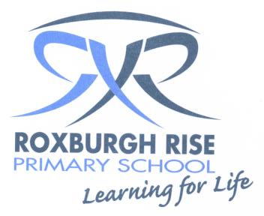
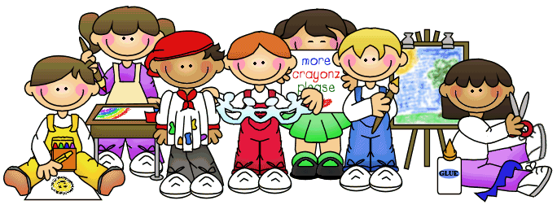

Year 3 Term 3 Overview 2019

Dear Parent/Guardians,

Please find an outline of the Grade 3 teaching and learning programs for Term 3. Due to the wide range of student abilities in each classroom, the teaching and learning program will be structured so that the learning needs of each student are catered for. Students will continue to use their tablets to deepen their understanding of concepts, raise engagement levels and support personalised learning through all areas of the curriculum.

Homework | Students are expected to read their home reader each night for at least 20 minutes and have a parent/guardian sign their diary to show that reading has been completed. You can assist your child by listening to them read, asking them questions about the text and reminding them to put their home reader back into their school bag.  Homework for this term consists of the following each week:  - One math worksheet related to what is being covered in the classroom.  - One spelling activity to be completed on students’ 5 words to help them practise and learn the words. Students are encouraged to practise their spelling words more than once throughout the week.  - One reading activity completed based on their home reading text or a library book.
English: | Reading sessions will involve a variety of learning experiences related to a range of texts. Students will be grouped with other students of like needs with strategies catered to developing each students’ reading ability.  Some of the main strategies focused on during term 3 in whole class tasks and small group/independent work will be:  - Paraphrasing  - Summarising  - Understanding different text structures and analysing the author’s choices  The theme of texts read during reading sessions will be linked to our inquiry unit ‘Community and Remembrance’ to assist students with building their knowledge of the topic.
 | Writing sessions will continue to concentrate on the process of planning, writing, revising, editing and publishing. This term, our writing genre will be information reports. After exploring the structure and features of an information report, students will be given the opportunity to plan, write, edit and publish their own piece. We will continue to use the 7 Steps for Writing techniques to enhance the quality of our informative writing. In the second half of the term students will have an opportunity to revise and learn more about narrative writing. During writer’s notebook sessions, students will continue to choose their own seeds and text types for writing.
Speaking & Listening will continue to occur daily in the classroom during sharing/reflection sessions and oral language activities. Students will be provided with opportunities to discuss what they have learnt and voice their thoughts and opinions about a range of topics.
Students will also enhance their speaking and listening skills through a presentation for our Inquiry unit, ‘Community and Remembrance’, where they will have the opportunity to share their learning with their peers. This will involve students planning, giving a practice presentation, receiving feedback to improve and then the final presentation.
 | Spelling is a part of the writing process. Spelling skills and strategies will be developed through spelling investigations each week, focusing on sounds relevant to students’ developmental stage.
Mathematics: | Term 3’s mathematics units are:
 | Number and Algebra:  - Multiplication and Division  - Fractions and Decimals | Measurement and Geometry:  - Solids – 3D Objects  - Volume, Capacity and Mass |  | Statistics and Probability:  - Chance and Probability
Inquiry Learning: | Our Inquiry unit for Term 3 is Community and Remembrance.  The focus questions for our unit are:  What cultures and celebrations are represented in Australia and how has it changed over time?  How has our local community changed over time?  Students will have the opportunity to explore:  - The first people who lived in Australia and how they have changed over time.  - How our community has changed over time including features that we have lost and gained.  - How and why people choose to remember significant events.  - Significant events that we celebrate in Australia.  - The importance of symbols and emblems.  The unit will conclude with a student led project. Students can choose how they address their understandings that they have gained throughout the unit. Students will share their new learning with peers.
Science: | The Science topic for term 3 is Physical Science, ‘It’s Getting Hot in Here’. Students will investigate how heat can be produced in many ways and can move from one object to another and how a change in the temperature of an object is related to the gain or loss of heat by the object. The unit will include conducting experiments to explore concepts such as friction, electricity, conductors and insulators in order to build student knowledge of how heat can be produced and can move from one object to another.

Kind regards,
Year 3 Teachers
Rebecca Spiteri, Marcella Loiacono, Dianne Saikaly, Lisia Halton, Lis Rossitto, & Lauretta Mallia.

