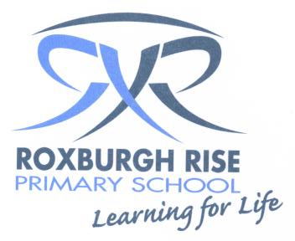
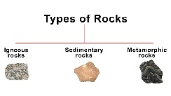 Year 4 Term 3 Overview 2019 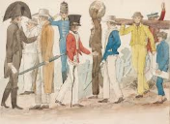

Dear Parents/Guardians,
Please find an outline of the learning and teaching programs for Term 3. Due to the wide range of student abilities in each classroom, the teaching and learning program will be structured so that the learning needs of each student are catered for. Students will also be using their iPads to deepen their understanding of concepts, raise engagements levels and support personalised learning through all areas of the curriculum.

English: | Reading Focus:  Reading sessions will involve a variety of activities related to a range of texts. Students will be grouped into reading groups with other students of like needs. The focus will be building on the students’ reading strategies including authors message, summarising, discussing facts and opinions, and reading fluency, along with other strategies that will be catering to your child’s needs. Students will also be exposed to various forms of texts. Dictionaries and glossaries will be used to expand the student’s vocabulary.
Writing Focus:
In Writing sessions students will be planning, composing, revising, editing & publishing written work in a variety of forms. They will be exposed to the different characteristics of a range of writing genres during writer’s notebook sessions. They will also be learning about the structure and features of historical fiction.

Speaking & Listening Focus:
Students will have many opportunities to speak in front of others, to encourage & increase their confidence. Students will be encouraged to put into practice the qualities of what makes a good speaker & listener. They will share experiences with others and points of view. Students will engage in oral presentations, discussions opportunities to verbalise and explain their point of view and offer constructive feedback.

Spelling Focus:
Spelling will be a part of the writing process. Students will be exposed to a word wall which incorporates Inquiry and Science Unit topic words. Spelling skills and strategies also will be developed through spelling investigations each week which will focus on the student’s needs. We will particularly be focusing on sentence structure and the correct use of punctuation.

Mathematics: | Number Focus:  - Multiplication  - Division  - Fraction | Measurement & Geometry:  - Volume  - Capacity  - Mass |  | Statistics and probability:  - Chance and probability
Inquiry Learning: | The Grade 4 inquiry unit for this term is ‘First Settlers’. Students will investigate why great journeys of exploration occur, Aboriginal and Torres Strait Islander life before European settlement and why Europeans settled in Australia. They will participate in a hands-on incursion where they will step into the shoes of people who lived during that age.
Science : | This term the students will be learning about Earth and Space Science completing a unit called Earth and Space. In this unit students will learn about geology (study of the Earth and of the rocks that comprise the Earth and how they change over time). They will participate in a range of activities where they will investigate rocks, soil, weather, erosion and phases of the moon.
Social & Emotional Learning | Social and emotional learning is incorporated into our day to day program. Students will be involved in mindfulness, meditation, organisation, Berry street and confidence building activities throughout the term.

Kind regards,
Year 4 Teachers

