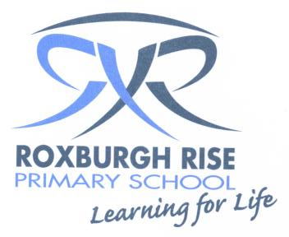
Year 5
Term 3 Overview 2019

Dear Parent/Guardians,

Please find an outline of the grade 5 teaching and learning programs for Term 3. Due to the wide range of student abilities in each classroom, the teaching and learning program will be structured so that the learning needs of each student are catered for. Students will also be using their iPads to deepen their understanding of concepts, raise engagement levels and support personalised learning through all areas of the curriculum.

English: | Reading sessions will involve a variety of learning experiences related to a range of texts. Students will be grouped with other students of like needs. Students will be exposed to effective comprehension strategies that help them to analyse information, integrate and link ideas from a variety of print and digital sources. Some of these include:
 | - Drawing conclusions  - Making inferences  - Authors purpose  - Thinking about the text |  | - Word meaning in context  - Making predictions  - Thinking beyond the text  - Thinking within the text
 | Writing sessions will concentrate on the processes of Planning, Composing/Recording, Revising and Publishing. Students will be writing information reports and persuasive texts. Writer’s Notebook will continue to be a part of the writing program where children are provided with opportunities to develop their writing skills in the different genres.
 | Speaking & Listening will be a daily event in the classroom during sharing/reflection sessions.
 | Spelling will be a part of the writing process and students will be exposed to a word wall which incorporates Inquiry Unit topic words. Spelling skills and strategies will be developed through spelling investigations each week which will focus on the student’s needs.
Mathematics: | Number:  - Fractions  - Decimals  - Number Patterns  - Multiplication  - Division | Measurement and Geometry:  - Shape Location and Transformation |  | Statistics and Probability:  - Chance
Inquiry Learning: | The units for Grade 5 this term are Health Education, Puberty and Drug Education.  The science unit for this term is Chemistry Solids, liquids and gases.

Kind regards,
Year 5 Teachers

