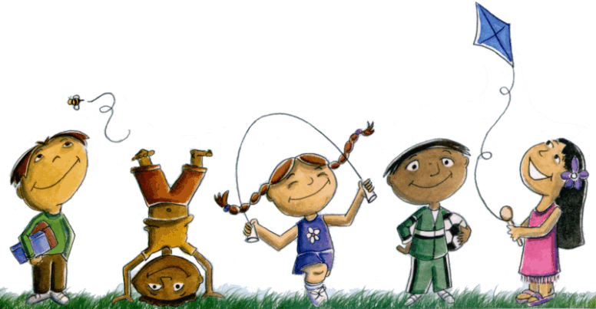
Foundation Term 4 Overview 2019

Dear Parents/Guardians,

Welcome back to the commencement of Term 4. We hope you all had a safe and fun filled break. Term 4 is a busy and productive term which includes swimming lessons, an excursion, Foundation Day Camp, celebrations and lots of learning. Please find below an outline of the learning and teaching programs for Term 4. Due to the wide range of student abilities in each classroom, the teaching and learning program will be structured so that all students are challenged and extended in their learning. In partnership with home we will continue to develop the students’ independence skills in order for them to smoothly make the transition to Grade 1 next year. We would appreciate your support by making sure that your child is responsible for handing in notes to their teacher and returning and borrowing their own home reading books. It is important that your child understands that from 9am they are to make their own decisions and choices for their learning. This will allow students to build their independence, confidence and time management strategies which are essential for lifelong learning.

We are encouraging all students to bring a bottle of water to school daily. This will help in maintaining concentration and water levels in the body.

HOME READING
You can help your child understand the importance of nightly reading by encouraging continuous experiences with books, listening to them read every night, asking questions about the story and reminding them to put their reading pack back into their bag before coming to school. Ensure that time is given to the learning of the Oxford or Toy Words each night and that students are encouraged to independently complete their spelling homework which will continue this term.
English | Reading  Reading sessions will involve a variety of activities related to a range of texts, letters, sounds and word patterns such as exploring words ending in ‘-at’ e.g. cat, mat, sat. Students will be exposed to various forms of texts, mainly fiction and factual texts, in both book and digital formats. Some of these include using their prior knowledge to help them understand texts, learning about the text features of a non-fiction text, identifying the facts and key words in a text, and using various comprehension strategies to check that students have understood what they have read. Students will continue to learn about the basic concepts of reading and books such as how to identify letters, high frequency Toy words and sentences in the book in both whole class shared reading experiences as well as in small teacher-led reading groups. When reading narratives, students will work on sequencing the events of the story, both orally and with pictures and writing.
Writing
Students will write personal recounts of experiences such as investigations during Indoor/Outdoor Discovery Learning sessions or reflections about experiences during language experiences, as well as other special events such as visiting the Golden Sun Moth Park during our Foundation Day Camp. During Term 4 students will continue focusing on correct letter formation and fluency when writing common words. They will also practice writing on dotted thirds. Students will be encouraged to sound out unfamiliar words using their phoneme fist and use full stops, capital letters and spaces in their writing. Students will also be encouraged to use word patterns to assist them with spelling unfamiliar words. Throughout the term there will be a focus on using new words that have been learnt to create different types of text, for example, poems, letters and information reports.
Speaking & Listening
Students will have many opportunities to speak in front of others to encourage and increase their confidence with their oral language development. In all areas of the curriculum they will be able to improve their speaking and listening and develop their language and social skills. There will be a focus on students structuring sentences using correct grammar, particularly when orally presenting during Discovery Learning, Show and Tell or Reflection time. During our unit on ‘weather’ students will have the opportunity to role play a News Reporter to their peers.
Maths | This term, during Mathematics sessions, students will be learning about the following:
Number and Algebra:
- Ordinal Number e.g. 1st position, 2nd position etc.
- Strategies for adding and subtracting
- Counting forwards and backwards
- Skip counting
Measurement and Geometry:
- Connect days of the week to familiar events and actions and o’clock time
- Language of position and movement
Inquiry  and  Discovery Learning | During our inquiry unit, students will explore the Weather. Students will participate in various activities to support their understandings of the key concepts including investigating the Seasons. During our WOW day, students will have the opportunity to experience different activities that happen in different weather conditions e.g. making hot chocolates and icy poles.  During Discovery Learning all children will work on investigations relevant to their interests and will be encouraged to be creative and imaginative as they develop their own projects. Discovery Learning promotes and encourages role playing, building and hands-on experiences as well as supporting children to develop their oral language and social skills.  Students will be attending an excursion to the Golden Sun Moth Park in Craigieburn as part of their Foundation Day Camp experience.  Pool safety will also be a focus this term to coincide with our swimming lessons.  During the term students will be building their social and emotional learning through activities such as learning how to collaborate with their peers, circle time conversations, problem solving and building on their conflict resolution skills.

Thank-you from the Foundation team
Brooke Paterno, Hayley Grycuk, Lauren Hart, Leanne Hainslin, Olivia Lukies, Sharnee Gambling and Elise Wilson

